Quan

For the exercise maker:

Part I:

Filter and graphic for average success rate, (histogram grahpic), example:

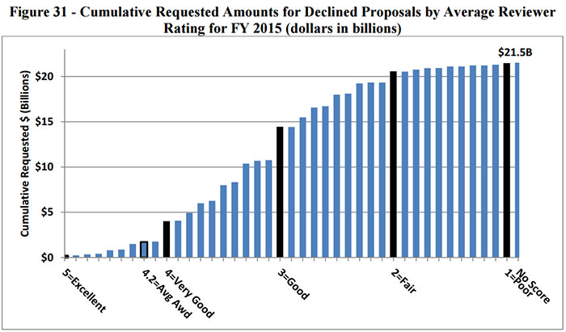

Part II:

Show success rate of each exercise and Coloring of the exercises :

If the success rate of the latter one increases, color it by GREEN

If the exercise has a success rate too high or too low, color it by RED

If the exercise is failed until you use a Hint, color it by YELLOW and color the Hint by GREEN

Otherwise it’s grey.